**Hotel Customers' Record Management.**

# Creation of database and tables:

This project consists of Create.java servlet program which must be run first in order to create database named "Hotel" and tables named "users" and "Customers". Make sure to change the username and password of mySql server to password added to your server.

# Execution of programs:

After successful creation database and tables

1. Run the login.jsp file. It has option for signing up new admin.

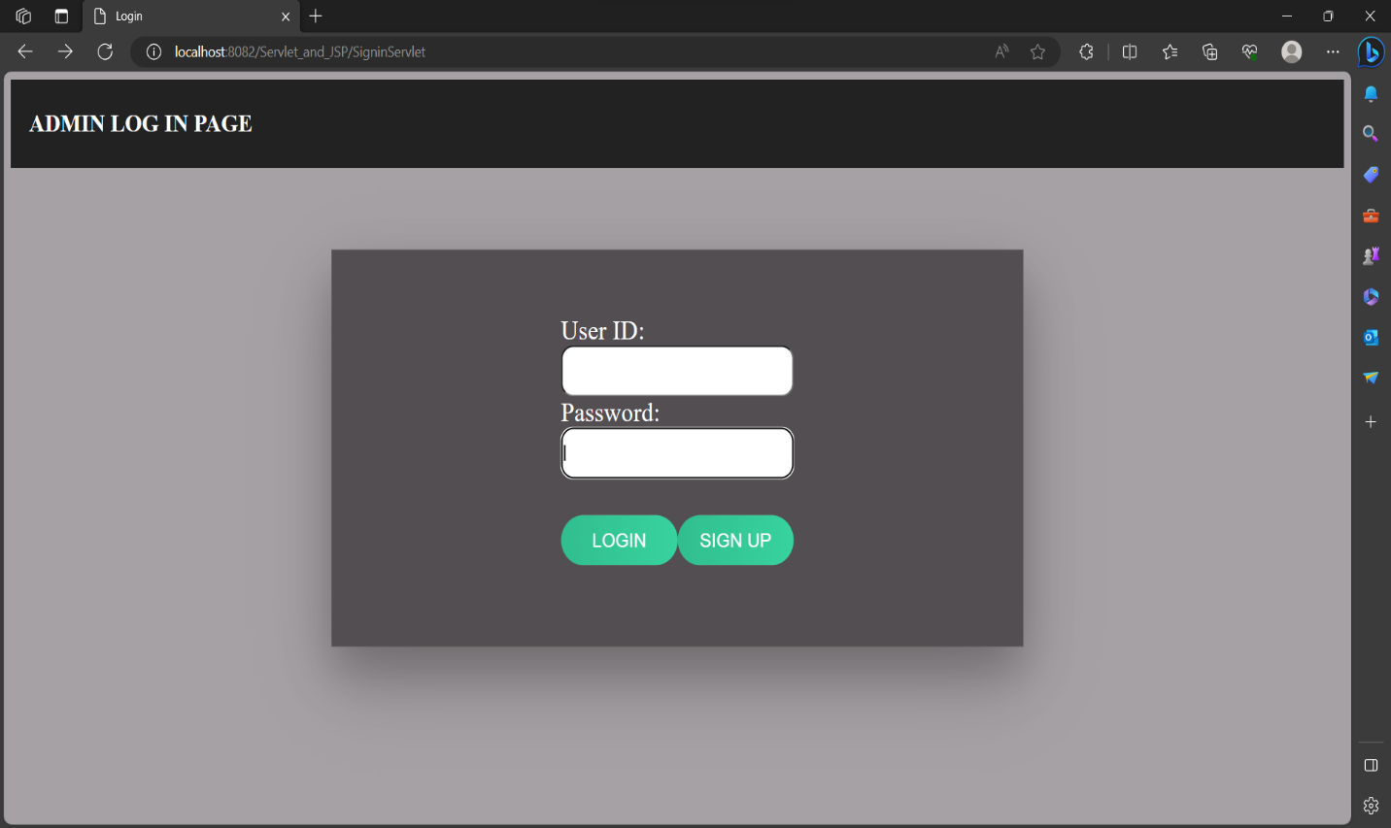

1. On clicking the signup button, the page redirects to signin.jsp page. The logic to insert data into "users" table is coded in SigninServlet.java servlet program.

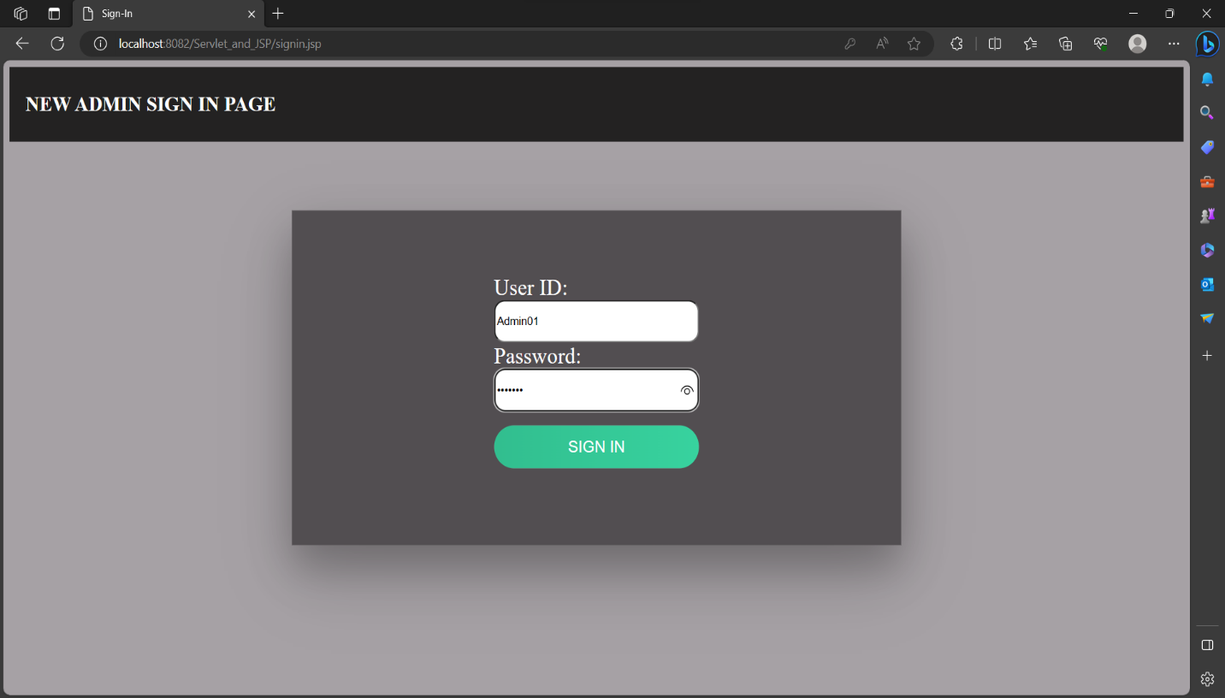

1. After signing in as a new user, the page is redirected back to login.jsp page. User can now login with their username and password. In case user is not registered, error message saying user not found is displayed in a popup message.

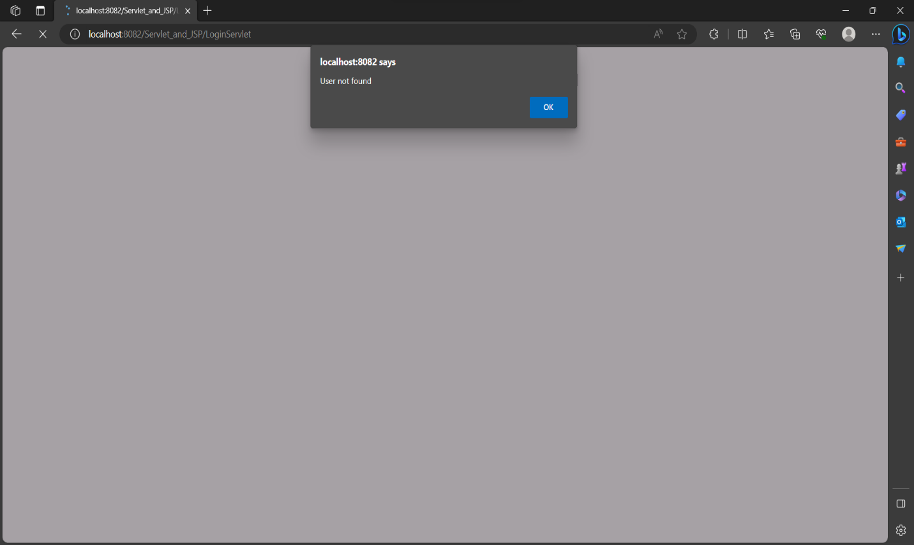

1. After successful login the user is redirected to frontpage. Here the user can enter the customer details in the form. This data is inserted into “Customers” table in the database.

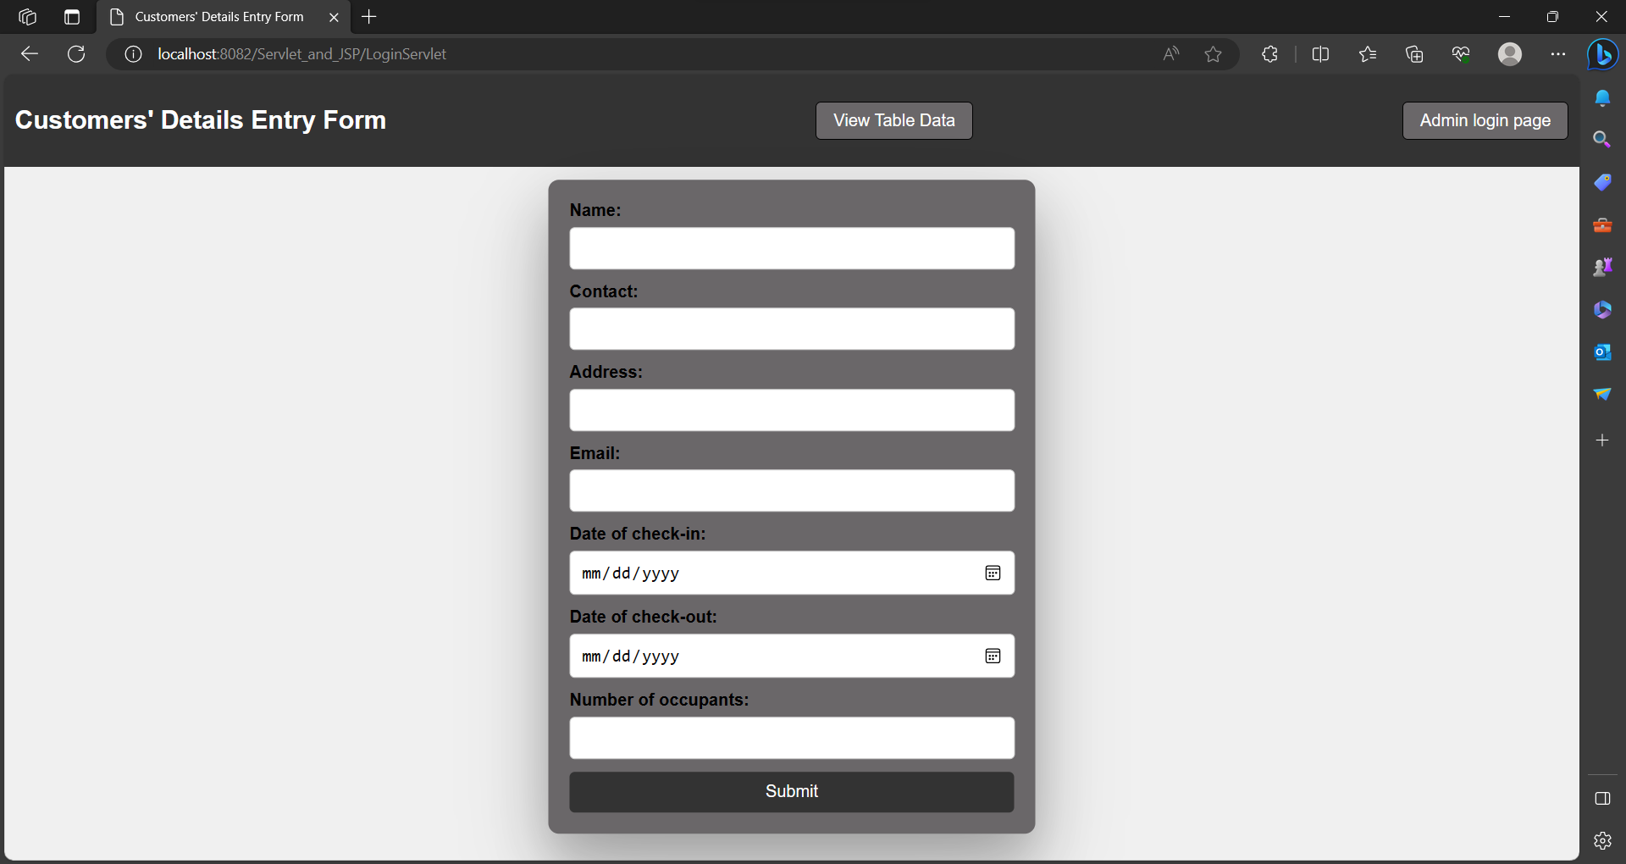

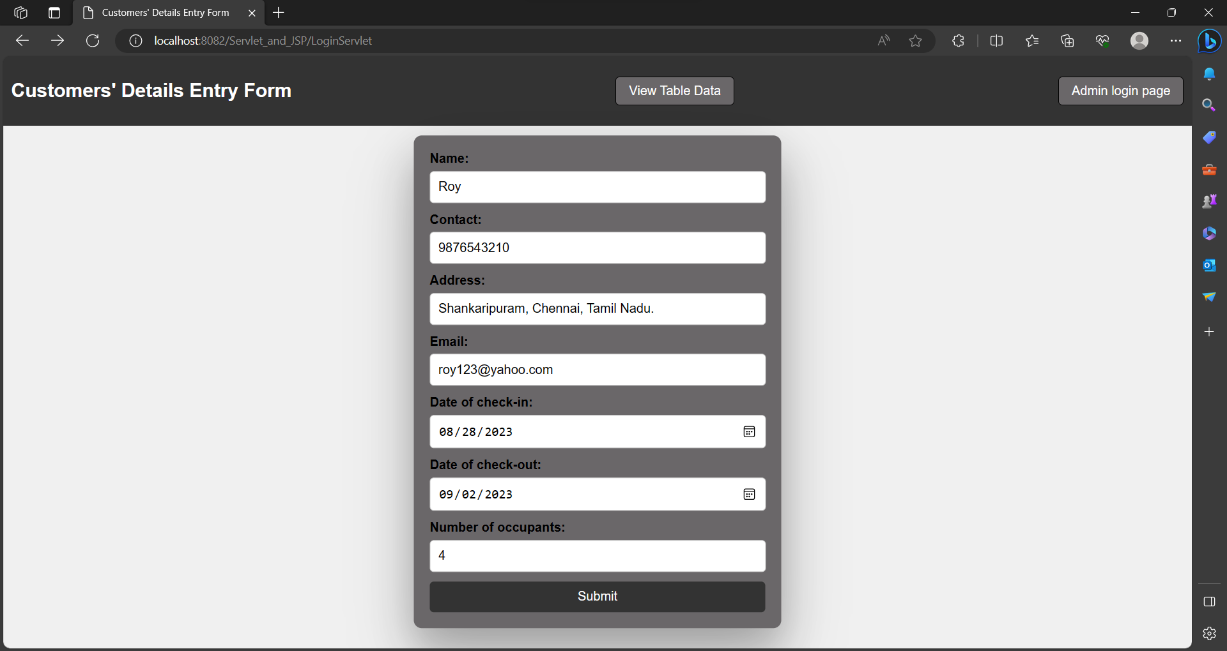

1. The content of the “Customers” table can be viewed by clicking on the “view table content” button at the top of the page. It redirects to displayData.jsp file. The logic of select query is coded in display.java servlet program. The data of table is being forwarded from servlet to JSP file.

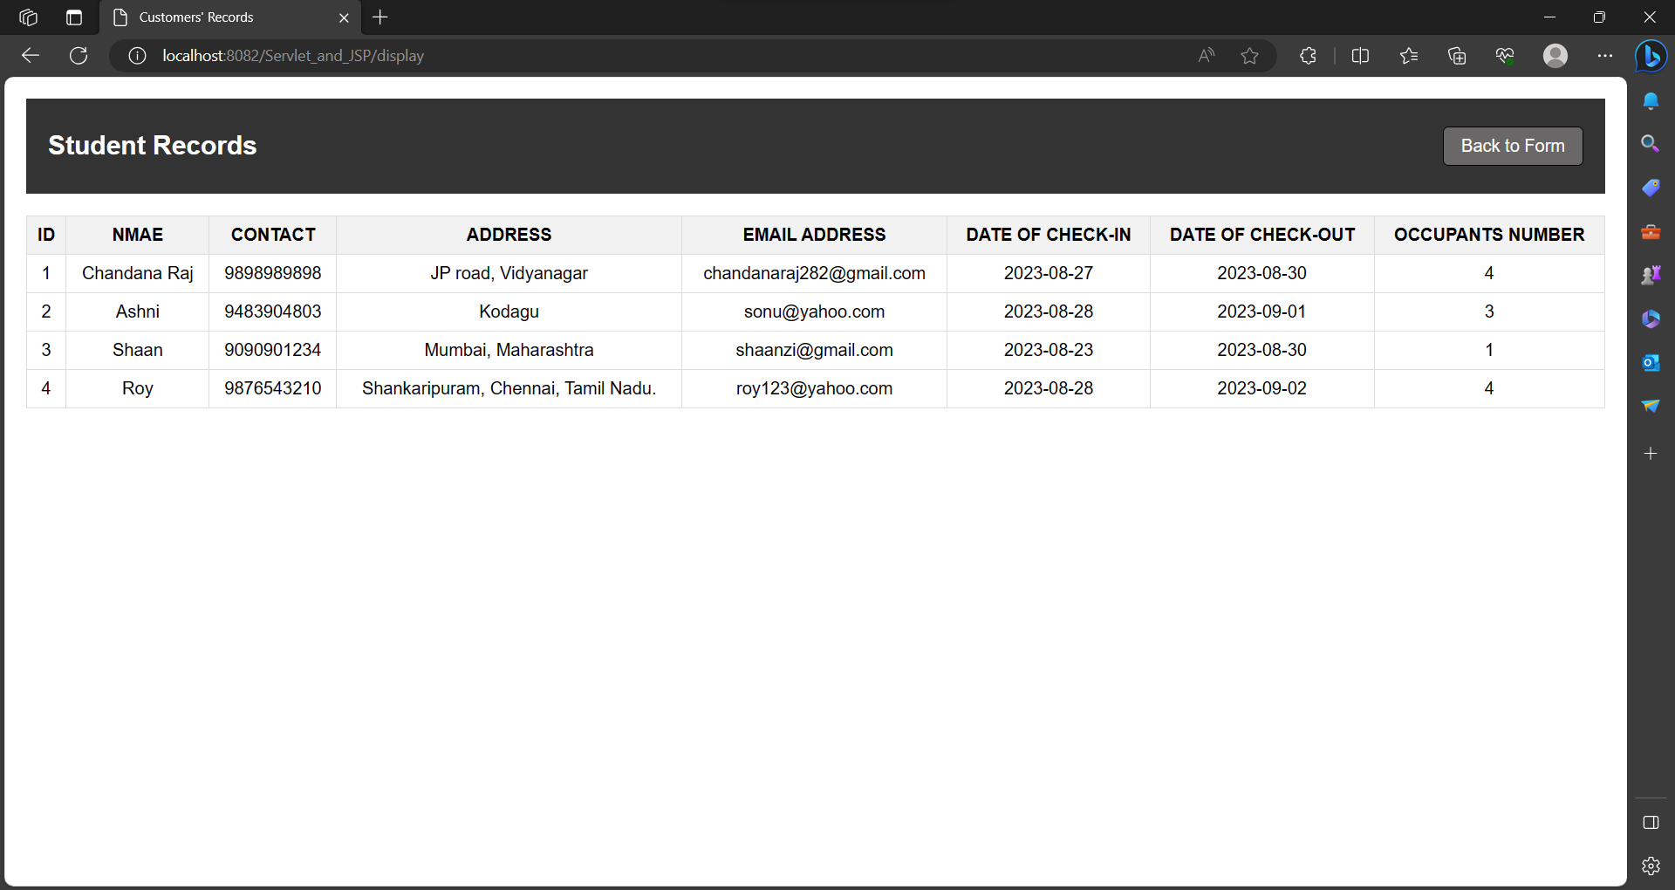

1. You can navigate from the page displaying the table content to frontpage where the form to enter details of new customer is available.

# Database:

A database named “Hotel” created when the “Create .java” file is executed. Two tables are created:

* 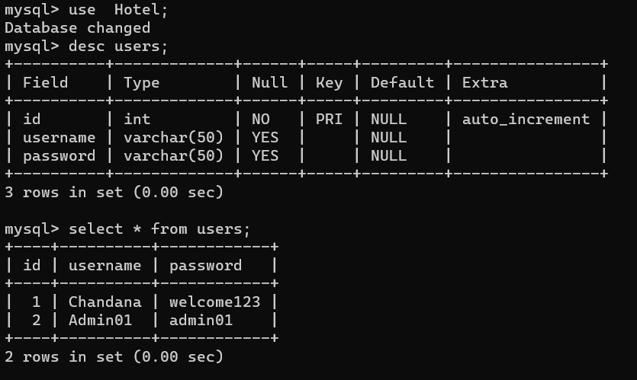Table named “users”:
* Data inserted “users” table:
* Table named “Customers”:

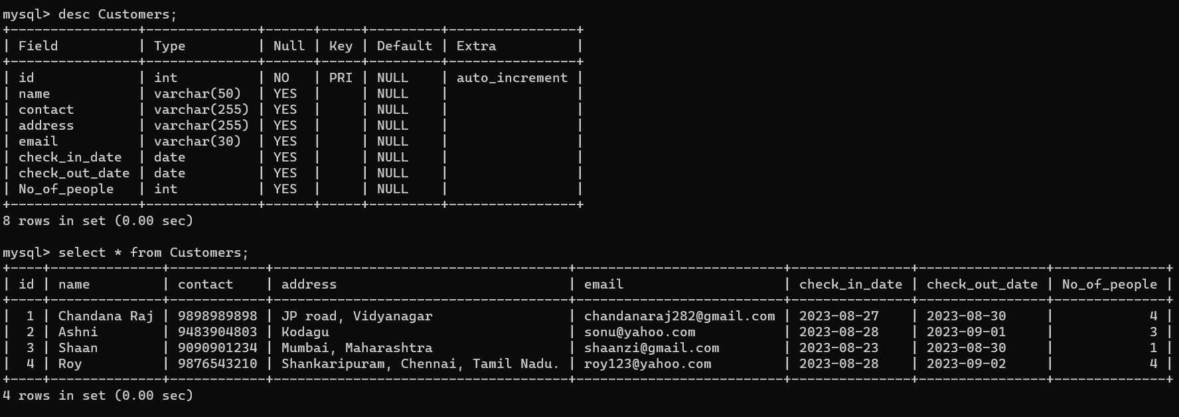

* Data inserted into “Customers” table:

